Appendix: New Programmes Participating in the School Nominations Direct Admission Scheme (SNDAS)

This year, HKU has 39 undergraduate programmes participating in SNDAS, with the addition of the following 9 programmes:

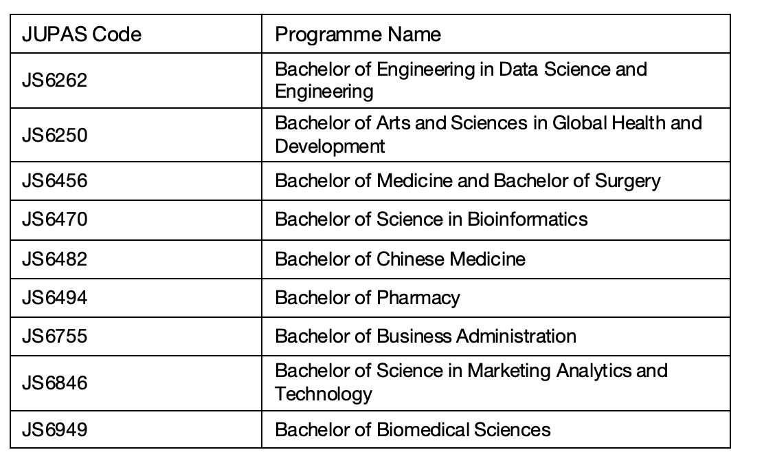

For details of all programmes participating in SNDAS, please visit:
https://admissions.hku.hk/sndas

